How to upload thesis into Neptun

Dear Students,
Hereby, I would like to inform you on the thesis uploading process.
According to the Code of Studies and Examination (Article 60 (6)) those who wrote their thesis and registered for the final exam are obligated to upload the thesis into the online study system.
In the current semester the deadline is April 3, 2018.

Important!
- only PDF file can be uploaded
- the maximum size of the document is 6MB
- you can upload the thesis only once
- after the successful uploading process the document cannot be modified

Please see the following guide:

The uploading menu is available under Studies / Degree thesis/Thesis application.
Here you can see the data of your thesis:
Please choose “Upload degree thesis”.
In the pop-up window you can select language and add the title of the thesis. Good to know that after the successful uploading process the title of the thesis cannot be modified.
By clicking on “Next” the “Upload degree thesis” window is available.
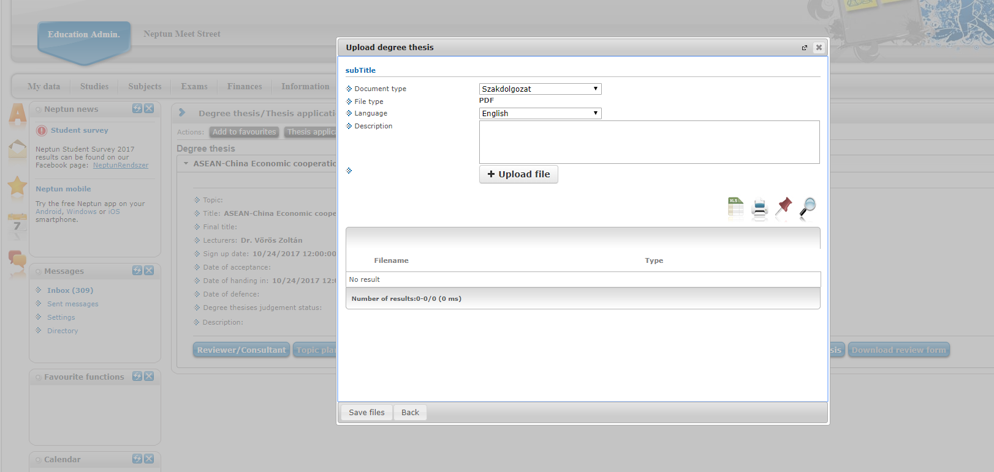
The uploading process can be started by clicking on “+ Upload file”.
At the end of the uploading click on “Save” and the system will send a message whether the process was successful.

